Assignment-16.4
Name: Penna Bhargavi
Batch:44
H.No:2303A52391
Task 1: Database Schema Design for an
Online Course Platform
Prompt:
Generate SQL INSERT statements to populate a database with sample data. The data should include at least 3 instructors, 4 courses, and 3 students. Ensure the data is realistic and properly structured. Also include SELECT queries to verify that the data has been inserted correctly.
Code:
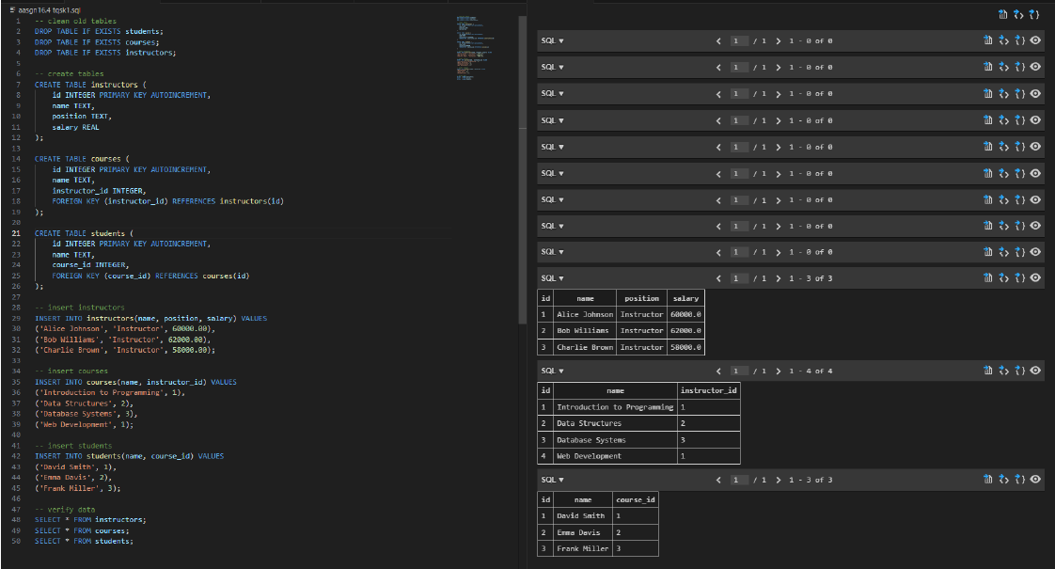
Observation:
The SQL INSERT statements were successfully executed without errors in SQLite. Three instructors, four courses, and three students were added to their respective tables. The SELECT queries confirmed that all records were correctly inserted and displayed as expected. The relationships between courses and instructors were maintained using instructor_id.
Task 2: Populate the Database with Sample Records
Prompt:
Generate SQL INSERT statements to populate a database with sample records. The database should include at least 3 instructors, 4 courses, and 3 students. Ensure proper relationships between tables and include SELECT queries to verify that the data has been inserted correctly.
Code:
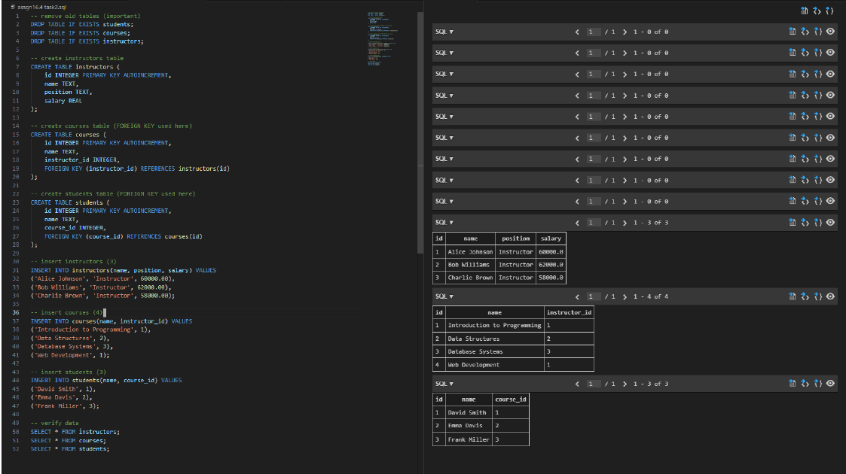
Observation:
The SQL INSERT statements were successfully executed to populate the database with sample records. Three instructors, four courses, and three students were added. The SELECT queries were used to verify the inserted data, and all records were displayed correctly without any errors. The relationships between instructors, courses, and students were maintained using foreign keys.

Task 3: Implement Core Database Operations (CRUD)
Prompt:
Generate SQL queries to perform CRUD operations on a database. The operations should include retrieving all courses, updating a student’s email address, deleting a course, and verifying each operation using SELECT queries to ensure correctness.
Code:
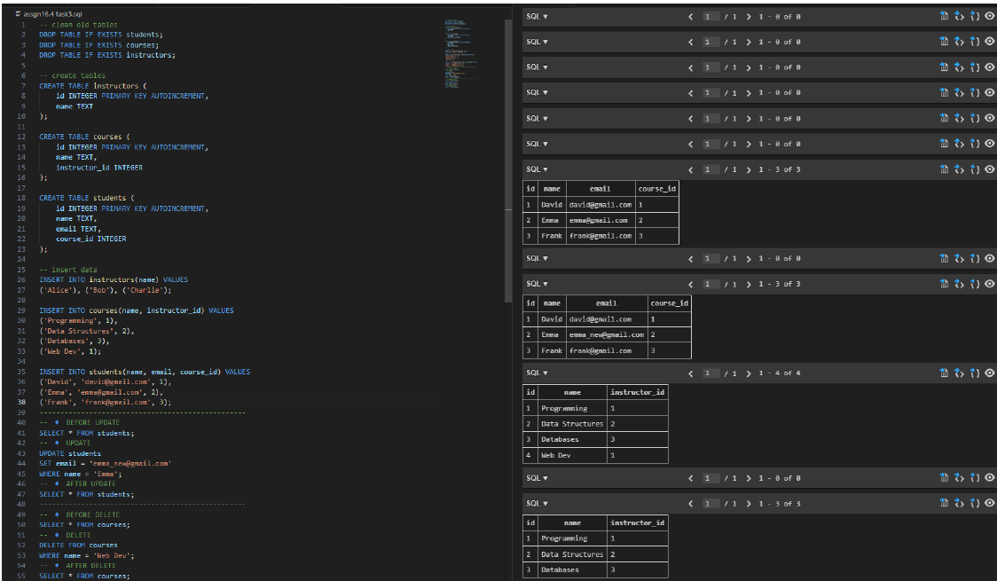
Observation:
The CRUD operations were successfully performed on the database. The SELECT query retrieved all course records. The UPDATE operation modified a student’s email address correctly, which was verified using a SELECT query. The DELETE operation removed a course from the database, and the change was confirmed by querying the courses table. No unintended data loss occurred during these operations.

Task 4: Reporting Using Aggregate Queries
Prompt:
Generate SQL queries to produce summary reports using aggregate functions. The queries should count the number of students enrolled in each course and list courses that have more than a specified number of enrollments. Use GROUP BY and HAVING clauses appropriately and verify the correctness of the results.
Code:
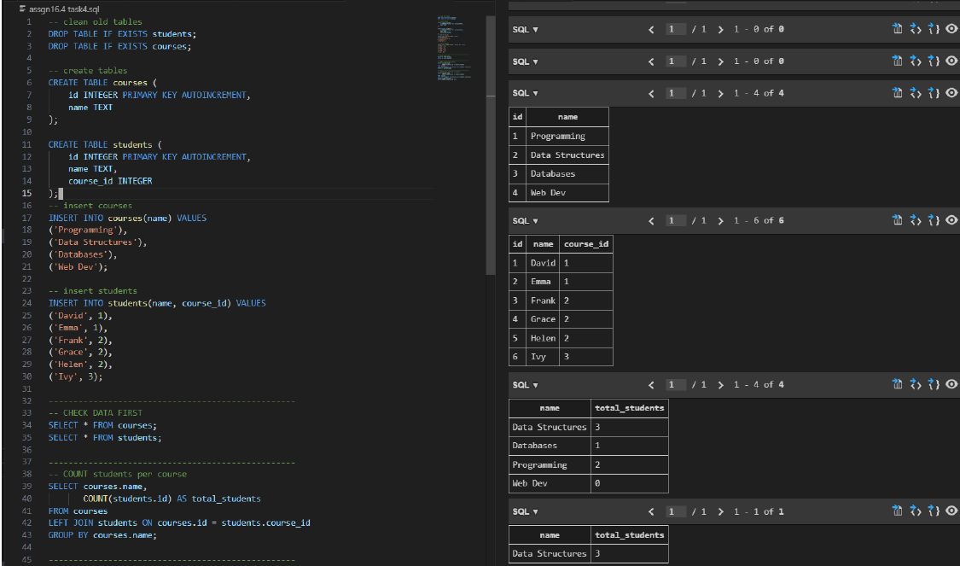

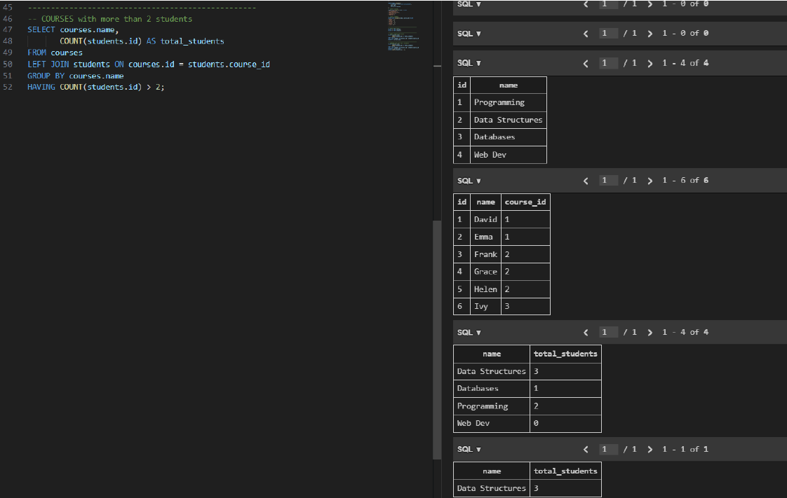

Observation:
Aggregate queries were successfully used to generate summary reports. The GROUP BY clause was used to group students by course, and the COUNT function calculated the number of students in each course. The HAVING clause was applied to filter courses with more than a specified number of enrollments. The results were accurate and matched the inserted data.

Task 5: Query Optimization with AI Suggestions
Prompt:
Analyze an existing SQL query that retrieves courses taught by instructors from a specific country. Refactor the query using efficient joins and suggest indexing techniques to improve performance. Compare the results before and after optimization to ensure correctness and improved readability.
Code:
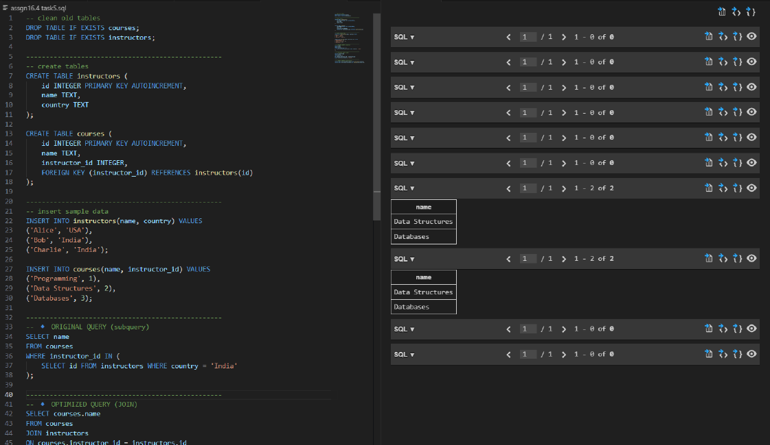
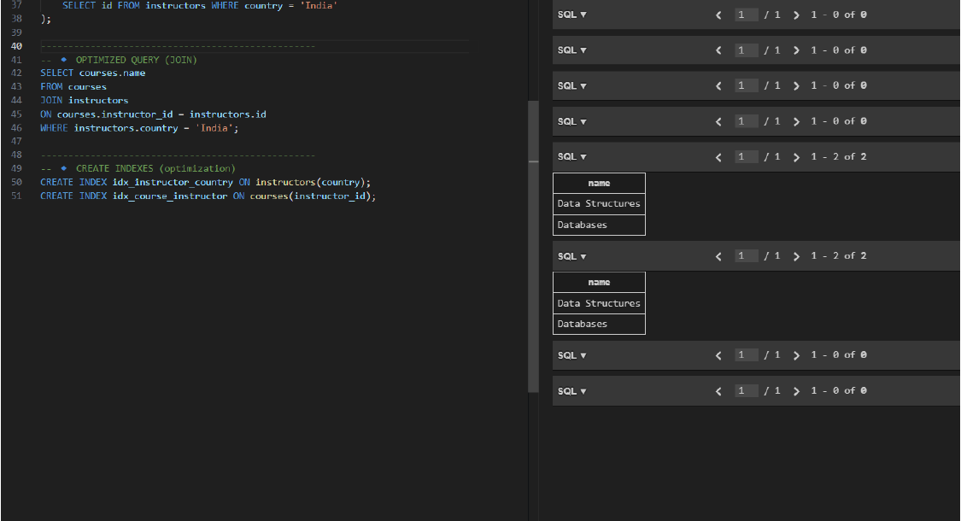

Observation:
The original query used a subquery to retrieve courses based on instructor country, which can be inefficient for large datasets. The optimized query replaced the subquery with a JOIN, improving readability and performance. Indexes were suggested on frequently used columns such as country and instructor_id to further enhance query speed. Both queries produced identical results, confirming correctness after optimization.

